Julius Caesar Act I literary terms

- Pun:

- Irony:

verbal

dramatic

situational

- Conflict (3 types):

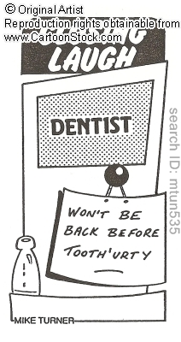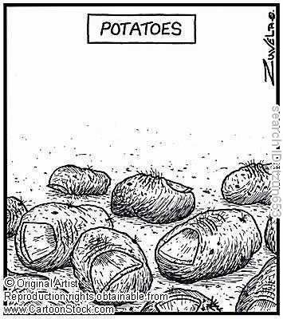
For each comic above, write down whether it’s one word with two meanings (A) or two words that sound similar and have different meanings (B). Then write down which word is being played on and what the two meanings are.

1. A / B
The word(s):
What the two meanings are:

2. A / B
The word(s):
What the two meanings are:

3. A / B
The word(s):
What the two meanings are:

For each comic, explain which type of irony it displays and how you can tell.

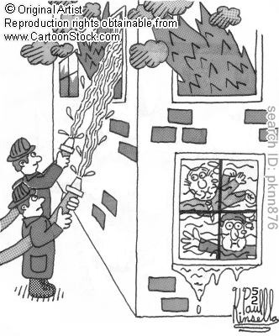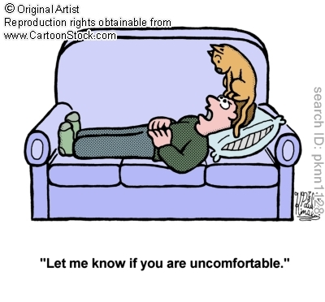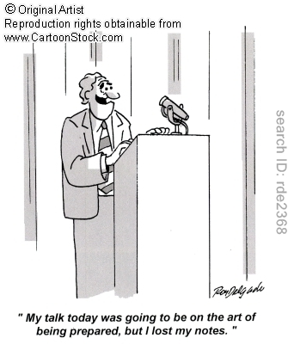
4.

5.

6.

For each comic, explain which type of irony it displays and how you can tell.

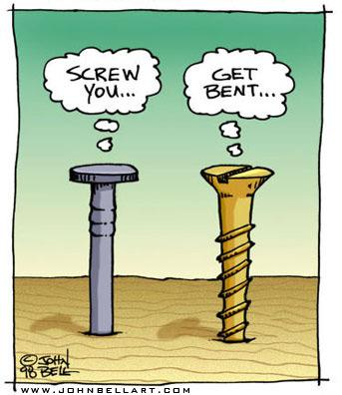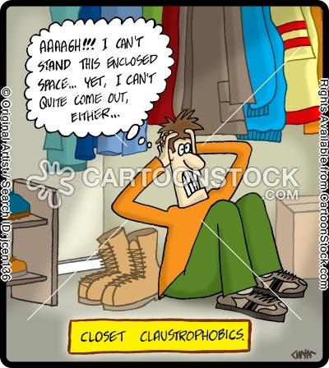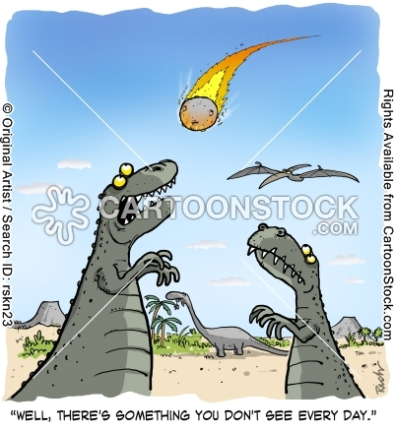

7.

8.

9.

